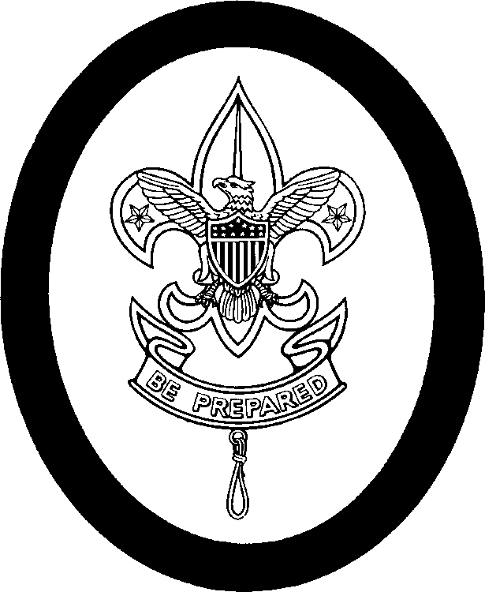

First Class Personal Growth Agreement Conference

Name: _________________________________Date________ Age: _____ School Grade: _______
I have been a member of the Scouts for _____ months, including _______ months
As a Second Class Scout. I passed my Progress Revue Board on ____ / _____ /_____

SCOUT SPIRIT:
I have shown my Scout Spirit by _______________________________________________________________

ADVANCEMENT:
From orienteering, I learned __________________________________________________________________
From cooking, I learned ______________________________________________________________________
From swimming, I learned ___________________________________________________________
How well can you tie the bowline knot and rescue bandages? _________________________________________
From your lashings, you learned _______________________________________________________________
Have you earned any Merit Badges? ____________________________________________________________
I find the difference between Progress Awards and Merit Badges is: ____________________________________
_________________________________________________________________________________________
I have appeared before ____ Troop Progress Review Boards. I think they are:
_________________________________________________________________________________________

CAMPING:
I have completed _____ nights of camping since joining the Troop.
Since becoming Second Class, I have been on the following campouts: _________________________________
__________________________________________________________________________________________
I liked the ________________ trip the best because ________________________________________________
Camping-out has taught me: ___________________________________________________________________

SERVICE:
I ( ) do /( ) don’t try to do a “Good Turn” daily. I have helped others by ___________________________________
________________________________________________________________________________

PATROL:
My Patrol is ( )poor ( ) fair ( ) good ( ) great. My job is ________________________________________________
I try to help the Patrol by _______________________________________________________________________
We meet ( )rarely ( ) don’t ( ) occasionally ( ) regularly. We do things to prepare for Troop Meetings. Yes No
We have a Patrol ( ) song, ( ) yell, ( ) flag, ( ) mobilization plan, ( ) meeting place, ( ) storage area.

TROOP:
I think the TROOP is ( ) Great, ( )Good, ( ) Fair, ( ) Mediocre, ( ) Poor
The things that I like most about being in the Troop are: _____________________________________________
The things that I enjoy the least are: _____________________________________________________________
I think being in the Scouts is: ___________________________________________________________________

First Class Personal Growth Agreement Conference Continued
Name______________________________

SCOUT SPIRIT:
I will continue to show my Scout Spirit by ________________________________________________________

ADVANCEMENT
I know that the skills portion of my advancement is now completed. From now on,
I will earn my Progress Awards by earning Merit Badges. I will continue to practice
The skills that I have learned and will try to teach the newer Scouts entering the
Troop these skills. _________ For my Star rank, I intend to pass these Merit Badges.
________________, ______________, ________________, ________________,
________________, ______________. Please circle the badges required for Eagle.
I have chosen these badges because __________________________________________________________
________________________________________________________________________________________

SERVICE:
For my Star Scout Service Project, I propose to __________________________________________________
_______________________________________________________________________________________

LEADERSHIP:
For my Leadership requirements for Star Scout, I submit that I will serve the Troop or
my Patrol in the following manner or position. ___________________________________________________
_______________________________________________________________________________________

PATROL:
I will continue to try to help my Patrol by ________________________________________________________
_______________________________________________________________________________________

TROOP:
I hope to see the Troop ____________________________________________________________________
I will help by _____________________________________________________________________________

** YOU WILL BE ASKED TO KEEP A NOTEBOOK TO LOG YOUR ADVANCEMENTS, SERVICE,
CAMPING, AND LEADERSHIP.

I INTEND TO COMPLETE THE REQUIREMENTS FOR STAR SCOUT BY _________/ _____/ ______

Respectfully submitted: ____________________________
( ) Accepted
( ) Not accepted _______________________________Scoutmaster. Dated ___/ __/ __
Recommendations:

First Class Rank Requirements for

Scout_____________________ Date __________
Date/Initials | # | Requirements
 | 1 | Demonstrate how to find directions during the day and at night without using a compass.
 | 2 | Using a map and compass, complete an orienteering course that covers at least one mile and requires measuring the height and/or width of designated items (tree, tower, canyon, ditch, etc.).
 | 3 | Since joining, have participated in 10 separate troop/patrol activities (other than troop/patrol meetings), three of which included camping overnight. Demonstrate the principles of Leave No Trace on these outings.
 | 4a | Help plan a patrol menu for one camp out that includes at least one breakfast, one lunch, and one dinner, and that requires cooking at least two of the meals. Tell how the menu includes the foods from the food pyramid and meets nutritional needs.
 | 4b | Using the menu planned in requirement 4a, make a list showing the cost and food amounts needed to feed three or more boys and secure the ingredients.
 | 4c | Tell which pans, utensils, and other gear will be needed to cook and serve these meals.
 | 4d | Explain the procedures to follow in the safe handling and storage of fresh meats, dairy products, eggs, vegetables, and other perishable food products. Tell how to properly dispose of camp garbage, cans, plastic containers, and other rubbish.
 | 4e | On one camp out, serve as your patrol's cook. Supervise your assistant(s) in using a stove or building a cooking fire. Prepare the breakfast, lunch, and dinner planned in requirement 4a. Lead your patrol in saying grace at the meals and supervise cleanup.
 | 5 | Visit and discuss with a selected individual approved by your leader (elected official, judge, attorney, civil servant, principal, teacher) your constitutional rights and obligations as a U.S. citizen.
 | 6 | Identify or show evidence of at least 10 kinds of native plants found in your community.
 | 7a | Discuss when you should and should not use lashings. Then demonstrate tying the timber hitch and clove hitch and their use in square, shear, and diagonal lashings by joining two or more poles or staves together.
 | 7b | Use lashing to make a useful camp gadget.
 | 8a | Demonstrate tying the bowline knot and describe several ways it can be used.
First Class Rank Requirements Continued for

Scout_____________________ Date __________

Date/Initials | # | Requirements
 | 8b | Demonstrate bandages for a sprained ankle and for injuries on the head, the upper arm, and the collarbone.
 | 8c | Show how to transport by yourself, and with one other person, a person  - From a smoke-filled room  - With a sprained ankle, for at least 25 yards
 | 8d | Tell the five most common signals of a heart attack. Explain the steps (procedures) in cardiopulmonary resuscitation (CPR).
 | 9a | Tell what precautions must be taken for a safe trip afloat.
 | 9b | Successfully complete the BSA swimmer test.*
 | 9c | With a helper and a practice victim, show a line rescue both as tender and as rescuer. (The practice victim should be approximately 30 feet from shore in deep water.)
 | 10 | Tell someone who is eligible to join Boy Scouts, or an inactive Boy Scout, about your troop's activities. Invite him to a troop outing, activity, service project, or meeting. Tell him how to join, or encourage the inactive Boy Scout to become active.
 | 11 | Describe the three things you should avoid doing related to use of the Internet. Describe a cyberbully and how you should respond to one.
 | 12 | Demonstrate Scout spirit by living the Scout Oath (Promise) and Scout Law in your everyday life. Discuss four specific examples (different from those used for Tenderfoot requirement 13 and Second Class requirement 11) of how you have lived the points of the Scout Law in your daily life.
 | 13 | Participate in a Scoutmaster conference.
 | 14 | Complete your board of review.

Note: Alternate requirements for the First Class rank are available for Scouts with physical or mental disabilities.
- The requirements for Tenderfoot, Second Class, and First Class ranks may be worked on simultaneously; however, these ranks must be earned in sequence.
*See the Swimming merit badge requirements for details about the BSA swimmer test.

