Resources
- Created by Charles Elwood – Bear Den 2012, Webelos Den 2013

- Kirk Park Overnight Website
  - http://www.miottawa.org/Parks/specs/kirkparklodge.htm
- Make Reservations using this site
  - https://www.miottawa.org/ParkReservations/searchFacility.do
- Main Costs
  - Event Fees $50 – For Residents of Ottawa County
  - Park Naturalist $25 – Guided Hike and class on venomous animals and poisonous snakes.
  - 1 Parent was assigned to bring Beef Stew
    - Would have taken too long to cook on the fire so the stew was prepared beforehand in Croc Pot. Cost was reimbursed at overnight
    - The Pieskos may share their stew recipe…it was really really good!
  - 1 Parent was assigned to provide S’mores, wet wipes, paper towels
    - 3 packs each of marshmallows, chocolate, and graham crackers.
    - 3 was too much for 8 kids and 5 parents. We could have used just 2 packs of each.
    - Approx $25. Cost reimbursed at overnight.
  - 1 Parent was assigned to provide ingredients for apple cobbler
    - Michigan apples, brown sugar, cake mix, butter, - etc according to recipe
    - Also brought whipped cream
    - Reimbursed at overnight
    - Recipe shown at link below:
    - Should have checked every 15 minutes. We overheated the cobbled and burned the top
    - http://www.texasbbqforum.com/viewtopic.php?f=61&t=19935
  - 1 parent was assigned to provide firewood and fire lighting equipment
    - Split firewood is already provided by parks department
    - Kindling, lighter and paper were needed.
  - 1 parent was assigned to bring breakfast
    - Donuts
    - Apples/bananas
    - Two types of cereal and milk (there is a fridge at the facility)
  - Other things to bring that helped:
    - Shovel fire coals on dutch oven
    - Dutch oven was borrowed from Boy Scouts to make cobbler
    - Oven mitt
    - 1 parent to bring beads/lanyard for craft project
    - 1 parent brought a large cooler of lemonade/other refreshment to drink.
- Packing List
  - Folding chairs are handy – but not necessary
  - Mat or something to help with the hard wood bunks
  - Sleeping bag
  - Ear plugs
  - Flashlights
  - Pillow
  - PJs
  - Toiletries
  - Pocket knives were initially allowed, but keeping the kids safe became a concern so we asked the kids to put the knives away.
  - Not allowed
    - Toy guns
    - No Nintendo DS – pack rules

Before The Event
Most important thing before the event is to inform people about the event, to get a commitment from parents on attendees, to pay deposit, to finalize the list of attendees, and to plan the arrival and return.

Facilities:
- Kitchen : stove, oven, sink, lots of countertop space, fridge.
- Bathrooms
- Heat and also an indoor fireplace. Split wood also stacked next to fireplace
- Firepit at the back of the building – large steel fire ring surrounded by 4 wood benches
- Parking – there are about 5 spots in front of the lodge. Some parents had to park in the main parking area and walk to the main lodge.

- Planning:
  - Dates fill up quickly so book as soon as you can. 6 months prior to event is recommended.
  - Check website and use the online calendar to check availability on dates that may work for your group.
  - Send dates to Cubmaster to submit credit card information to pay for the booking
  - You will receive email with Rules for using the main lodge.
    - Note : The gates to the park are locked at night. There is a key in the closet of the main lodge.
  - Next contact the Ottawa Parks department and ask for Scout programs.
  - A naturalist will contact you and can help check availability for a parks naturalist to lead a hike and do a lesson at the main lodge.
    - Cost for lesson and hike is $25.
    - Lesson is for poisonous plants and venomous animals native to Michigan.
  - After this date, I sent out a few planning reminders and itinerary emails to the parents and scouts. Plan carpool.

Things to add:
emails with parent assignments,

The Event
Prep:
- Parents showed up at arranged time at Kirk Park
- Initially 40 minutes was planned for Beef Stew prior to the nature hike and lesson
  - Beef Stew was prepared ahead of time in croc pot but had cooled down.
- As Scouts and parents arrived, each went to the main lodge and setup their sleeping areas and then went to the back of the lodge to play in the woods.
  - It was good to set boundaries for where the kids could venture into the woods
  - There seemed to be houses and residential area not too far from the main lodge
  - Other hikers and dogs not on leashes would stroll through the area
  - Might be good to set ground rules such as not climb trees at the beginning.
Arrival
- Chad and I were the first to arrive about 20 minutes before the event started.
- As people rolled in, I met them at the parking lot near the lodge and told them where to take sleeping bags.
- Bunks are arranged along two walls. Kids and parents picked their bunks and setup their sleeping bags. The middle of the lodge was filled with about 6 picnic tables
Pre-Hike:
- Before our hike, we had about 20 minutes to prep a few things:
  - Plugged in Croc Pot to warm stew
  - I reviewed “Leave no Trace” pledge with the Scouts and discussed the reason for each item in the pledge.
  - In prior years, cub scouts also earned their wittling badge. Since we had earned previously some scouts brought their own pocket knives, however, after the first cub scout cut his finger, I ruled out knives for the rest of the night.
Nature Lesson and Nature Hike
- Curtis from the West Ottawa Parks department showed up right on time.
- He started his lesson in the lodge and showed pictures of the 1 poisonous rattlesnake that is found in Michigan.
- He also taught the kids about poison ivy and showed some pictures.
- Next we started the hike around the park.
- Curtis took the kids to the observation area by the beach and taught the kids a lesson about how the sand and dunes are formed and also talked about the plants that are found in the dunes area. He also spent a fair amount of time talking about trees in the area and why and how they change colors in the fall.
- Next we walked up the dunes and he kept quizzing the kids on plants along the way, trying to find poison ivy. We did finally find some ivy in berry form.
- He also stopped along the way and called out to birds and played back some bird calls to try and attract a certain bird that was migrating through the area.
Dinner and Fire Put fun
- Next we got back to the main lodge.
  - Alan started the fire
  - Chad served the beef stew
  - Then we roasted s’mores on the fire pit
  - Chad and Jeff prepared the apples and laid out the apple cobbler.
  - We then placed the Dutch oven in the fire pit
    - The fire was super-hot and we burned the top of the cobbler after about 30 minutes.
    - Cobbler was delicious with some whipped cream on top, although the kids didn’t really eat the cobbler. Maybe I had already stuffed them with s’mores and beef stew.
Rest of the night
- For the next few hours, the kids played hide and seek with flashlights around the lodge
- Some parents stayed around the fire pit and watched the kids that were outside
- Some parents stayed inside the lodge and watched the kids that were inside
- I set a rule that no sticks were allowed in the firepit
- Lights out probably didn’t occur until about 11:30 pm or so.

Breakfast
- In the morning I had an alarm set and got everybody up around 7 AM.
- Parents prepped breakfast in the kitchen and served to the cub scouts through a window in the kitchen. Coffee would have been a nice adder.
- Kids ate cereal, bananas, apples and had powdered donuts.
- Then we cleaned and packed all supples.
- There are some cleanup rules that are provided with confirmation of the overnight from the parks department, I believe they are:
  - Clean spills and wipe down tables
  - Make sure trash is in bins. Park dept will pick up the bins
  - Sweeping is done by the parks department
  - Park locks the gate at night. There is a key in the storage room in the lodge.
  - We left the lodge unlocked since the parks dept was coming to clean up after the event.
- Parents drove home with their Scouts after the event.

Comments/Tips/Notes:
- Kids wandered into the woods, so setting rules early about boundaries was important.
- First aid kit was handy a couple of times.
- I should have planned more games between the meal and bedtime. Chad brought paracord, but that wasn’t enough to keep the kids occupied the whole time.
- Book early. The weekends really filled up fast in October.
- Prep-heat the food early. Kids were really hungry and cranky during the hike. We had planned to have the food before the hike but the stew showed up cold. Note : Heat was very hot in the building but not adjustable, so we had to open windows and doors to cool down the building.
- I probably should have made a rule that parents needed to attend with Scouts as we had parents who left later that evening. (Note : Park closes the gate in the evening. In the closet, there is a set of keys for the gate)
- Cleanup was defined in the rules. I believe all you need to do is put all trash in bags in the bins provided and park will pick up the trash and sweep. Picking up and wiping down of all tables is suggested.

Pictures
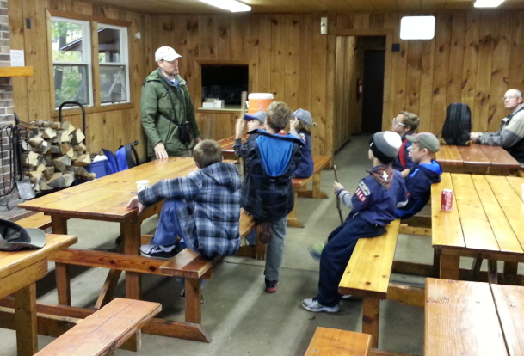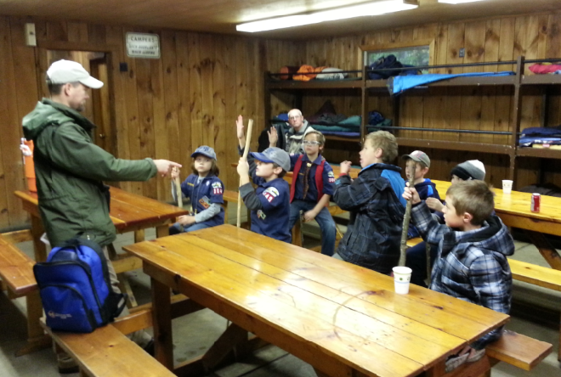
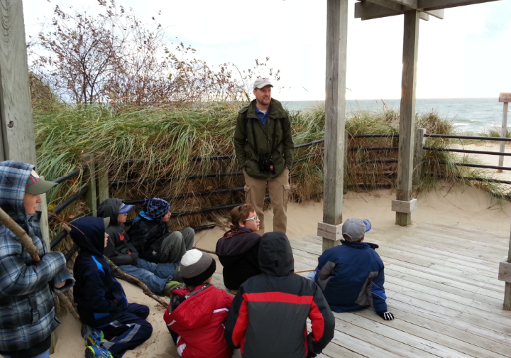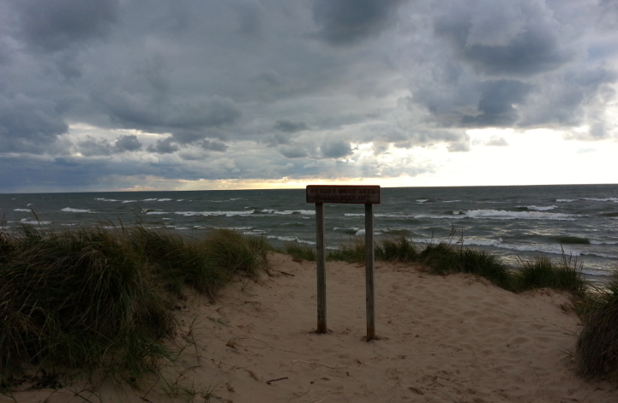
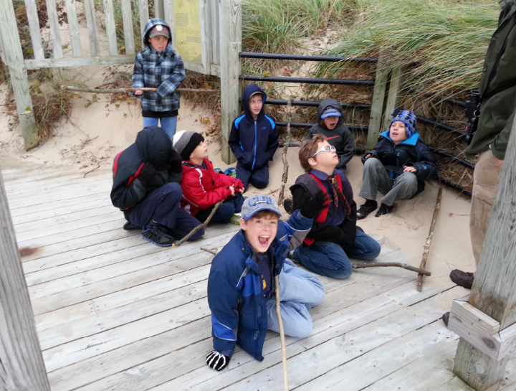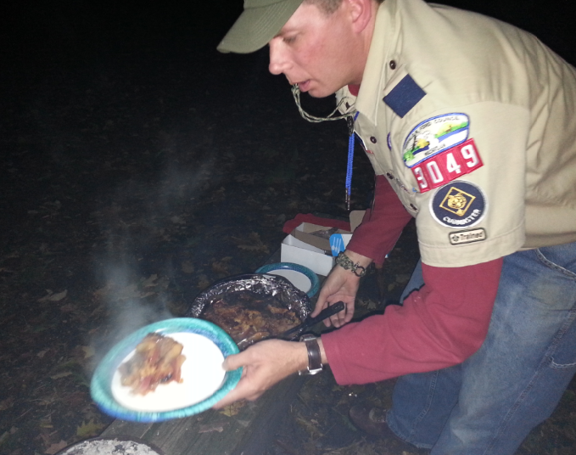
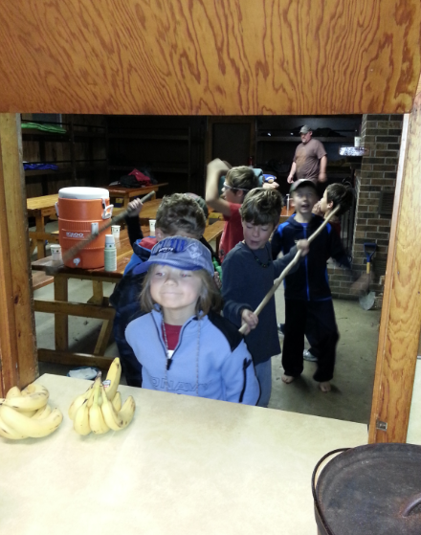

Appendix

Notes from Bull Bush – Leader that took a den in 2012
- Bill chose to have Pizza delivered or maybe he brought pizza
- Bill finished the whittling chip at this outing.

Information Documents from the Parks Department :
Once you confirm, you get the attached confirmation sheet with some rules:

Email I sent prior to trip:
Hi Scout Parents,

Reminder that Kirk Park overnight is coming up this Saturday night and into Sunday morning. Oct 26-27th.
Please note that this was initially planned for Friday night, but that has changed so the older emails have incorrect dates.

Kirk Park Planning:

Arrive around 4 PM - Park and Meet at Kirk Park Parking Lot
4:15 - 5 PM -> Beef Stew - to be provided by the Piesko family
5 PM -> Naturalist will arrive and take us on a hike (1.5 hours) were proper outdoor wear.
6:30 PM -> Start Fire and Jeff Mooney to start apple cobbler in dutch oven on fire
7:30 PM - Smores
9:00 PM -> Lights out
8:00 AM wake up and breakfast provided by Mitchem family
9:00 AM packed up and leave for home

Note: Sleeping is in the main lodge. Tents are not allowed.
Bring sleeping bags, sleeping mats to use in the lodge. There is a fireplace and heat.

Attached is chaperon information that the Parks Service ask that I provide to all parents attending the nature hike.

Kirk Park Overnight Planning | Yes/No | Parent
Joshua Elwood | 1 | 1
Alexander Spilotro | 1 | 1
Jaysen Hoezee | 1 | 1
Andrew Neckerman | no overnight | no overnight
Sean Dummer | 1 | 1
Ethan Allen | 1 | 0
Keith Pas | 1 | 1
Connor Mooney | 1 | 1
Ryan Mitchem | 1 | 1
Derek Piesko | 1 | 1
Gabe Hoberman | - | -
Lucas McCoy | - | -
Andrew Geren | - | -
TJ (Tieren) Mann | - | -
 | 10 | 9
Totals | 19

Email from Silversides Organizer

Email I sent after completion of the overnight

Sorry for the late email, but I wanted to give everyone an update on the Kirk Park Overnight!

We had a blast and a feast!
Thanks to the Piesko family for bringing the beef stew! That really hit the spot and was perfect for an overnight campout.
The Smore's were a hit with the kids and the apple cobbler in dutch oven was also yummy (although the dads ate most of that)...thanks Mooneys!
Thanks to Chad for bringing extra project material to keep the kids busy later in the evening. We made lanyards with beads and such.
Thanks to Alan for tending the fire and keeping that going late into the night.

The kids had a great time and the nature hike guided by Curtis from the Parks department was fantastic.
I now know about the only poisonous snake in Michigan and we spent a ton of time identifying poison ivy(who knew they had white berries that are just as bad as the leaves).

The kids that attended earned the following
Outdoorsman 2,3, and 5
Naturalist 7
Leave No Trace Award 1

